BUILD AND SECURE A MINI ENTERPRISE NETWORK
Capstone Project Report
Student Name: Rishitha Bandaru
Learner ID: 17947
Batch / Team: Cyber Security July 2026
Assessment Target: Ubuntu web server (Nginx 1.24.0) at 192.168.206.5 in a two-VM VirtualBox lab network
Assessment Date: 19 October 2026
Tools: Kali Linux, Ubuntu, VirtualBox, Nmap 7.95, Wireshark, UFW, curl

1. Objective and scope
This project built a small virtual network in VirtualBox, scanned it with Nmap, captured its traffic with Wireshark, and hardened the exposed service with a host firewall.
The lab contains two virtual machines: a Kali Linux machine used as the assessment host, and an Ubuntu machine running an Nginx 1.24.0 web server. Both sit on the 192.168.206.0/24 subnet. All results below come from this two-machine setup.
Tools used: VirtualBox, Kali Linux, Ubuntu, Nmap 7.95, Wireshark, UFW, curl and ping.

2. Network architecture
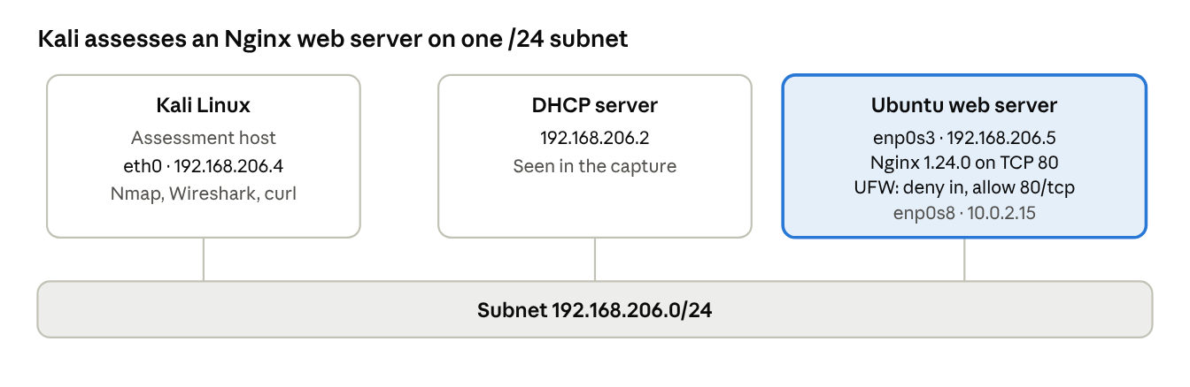
lab topology · 2 VMs on 192.168.206.0/24
Kali (192.168.206.4) scans and browses to the Ubuntu server (192.168.206.5), which serves a web page through Nginx on TCP 80. The firewall shown on Ubuntu is the UFW configuration applied during hardening (section 8). Ubuntu's second adapter (10.0.2.15) is shown for completeness.

3. IP address table
Both machines received their addresses dynamically on 192.168.206.0/24. The capture also shows a DHCP server at 192.168.206.2.
Host | Role | Interface | IP address | Subnet | Assignment | MAC address
Kali Linux | Assessment host | eth0 | 192.168.206.4 | /24 (255.255.255.0) | Dynamic (DHCP) | 08:00:27:36:4b:58
Ubuntu | Web server (Nginx) | enp0s3 | 192.168.206.5 | /24 (255.255.255.0) | Dynamic (DHCP) | 08:00:27:28:76:45
Ubuntu | Second adapter | enp0s8 | 10.0.2.15 | /24 (255.255.255.0) | Dynamic (DHCP) | not captured
DHCP server | Address assignment | n/a | 192.168.206.2 | /24 | n/a | 08:00:27:9b:22:7a
Kali also lists a docker0 interface (172.17.0.1/16) in state DOWN (NO-CARRIER); it carries no lab traffic.

4. Configuration documentation
The two machines were configured, then checked for addressing, connectivity, web service and name resolution.
IP configuration. ip -4 addr on each machine confirms the addresses in section 3.
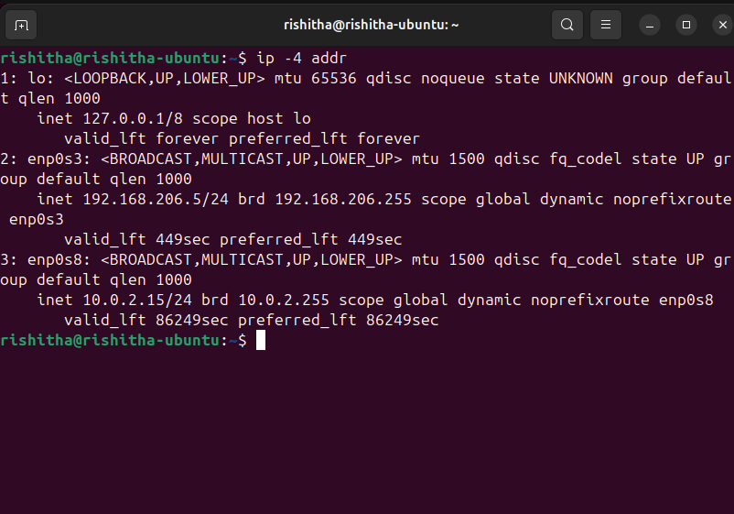
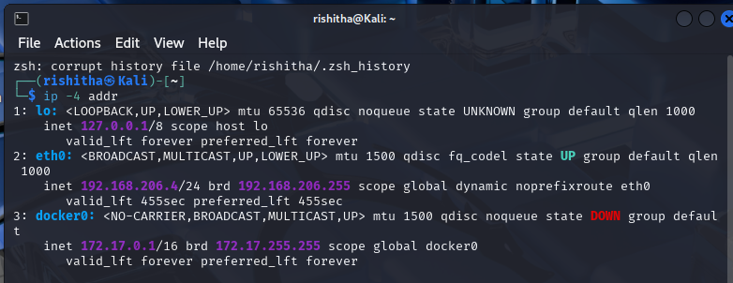
Connectivity. Kali pinged the Ubuntu server with ping -c 4 192.168.206.5: 4 packets sent, 4 received, 0% packet loss, round-trip min/avg/max/mdev 1.620 / 3.014 / 4.985 / 1.227 ms, TTL 64.
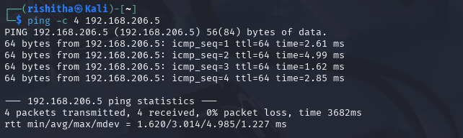
Web server. Nginx was enabled and started on Ubuntu with sudo systemctl enable --now nginx, and systemctl is-active nginx returned active.
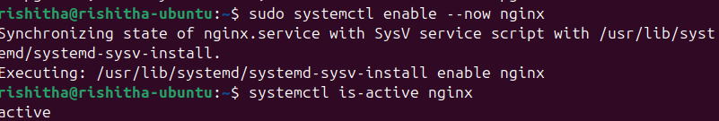
From Kali, curl -I http://192.168.206.5 returned HTTP/1.1 200 OK with Server: nginx/1.24.0 (Ubuntu), Content-Type: text/html and Content-Length: 615.
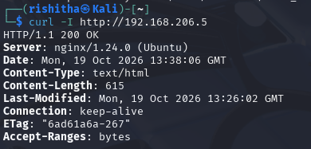
DNS. On Ubuntu, getent hosts archive.ubuntu.com resolved the name to IPv6 addresses (for example 2620:2d:4002:1::102 and 2a06:bc80:0:1000::17), showing name resolution works.
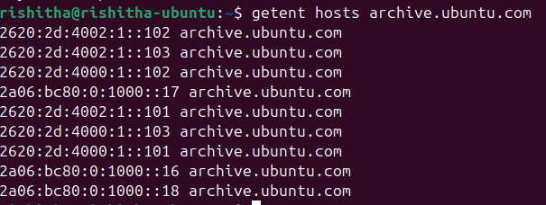

5. Nmap results
The scan found one open port on the Ubuntu server: 80/tcp, running nginx 1.24.0.
Command run from Kali on 19 Oct 2026 (Nmap 7.95): nmap -sV -oN ~/Mini_Enterprise_Network/03_Nmap_Results/ubuntu_scan.txt 192.168.206.5
Item | Result
Target | 192.168.206.5 (host up, 0.0032 s latency)
Ports scanned | Nmap's default 1000 TCP ports: 999 closed (reset), 1 open
Open port | 80/tcp, http, nginx 1.24.0 (Ubuntu)
MAC address | 08:00:27:28:76:45 (Oracle VirtualBox virtual NIC)
OS info | Linux (CPE: cpe:/o:linux:linux_kernel)
Scan time | 20.72 seconds, 1 host up
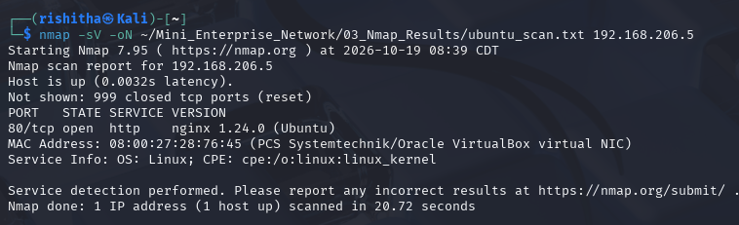

6. Wireshark evidence
The capture shows the full HTTP exchange between Kali and Ubuntu in clear text.
Traffic was captured on Kali's eth0 and saved as lab_traffic.pcapng (20 packets).
Packets | Protocol | What it shows
1–3 | TCP | Three-way handshake from 192.168.206.4:59498 to 192.168.206.5:80 (SYN, SYN-ACK, ACK)
4–7 | HTTP / TCP | HTTP GET request (packet 4, 147 bytes) and the server's response (packet 6, 928 bytes)
8–10 | TCP | Connection closed with FIN/ACK in both directions
11–12 | mDNS | Multicast queries for _ipp._tcp.local (IPv6 and 224.0.0.251)
13–16 | ARP | Kali and Ubuntu resolve each other's MAC addresses
17–18 | DHCP | Request and Ack from 192.168.206.2
19–20 | ARP | Kali resolves 192.168.206.2
With the http display filter, two packets remain: the GET request from 192.168.206.4 to 192.168.206.5 and the reply. The request headers, including Host: 192.168.206.5 and a curl User-Agent, are readable in the packet bytes.
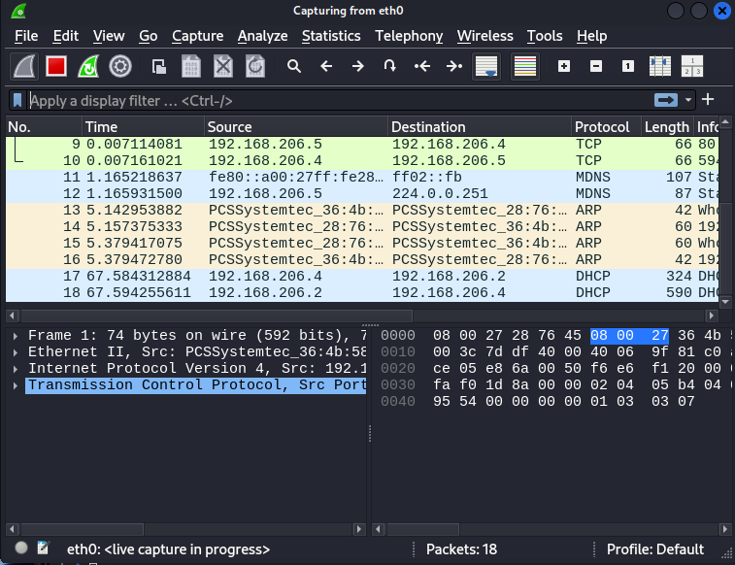
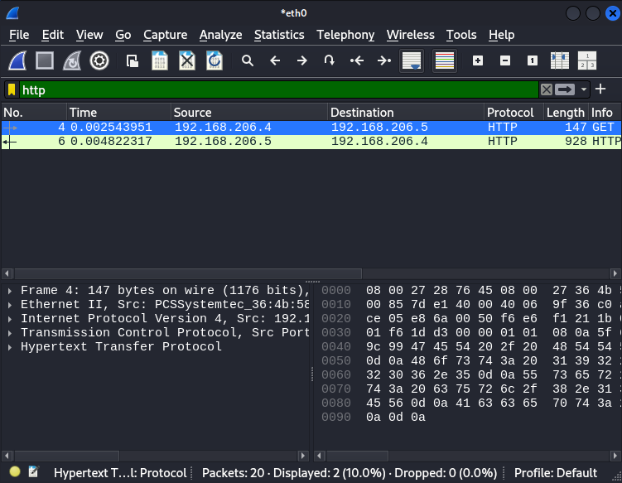

7. Security findings
The Ubuntu web server had no active firewall, and its only service ran over unencrypted HTTP with a visible version.
# | Finding | Evidence
1 | Host firewall inactive: UFW reported Status: inactive before hardening, so nothing filtered inbound traffic on the Ubuntu server. | sudo ufw status on Ubuntu
2 | Web traffic is unencrypted: the HTTP GET request and response crossed the network in clear text and were readable in Wireshark. Only port 80 was open in the scan. | Wireshark capture, http filter
3 | Server version is disclosed: both the HTTP Server header and Nmap service detection reveal nginx/1.24.0 (Ubuntu). | curl -I output, Nmap -sV scan
4 | Small exposed surface (positive): of 1000 TCP ports scanned, only 80/tcp was open and 999 were closed. | Nmap scan
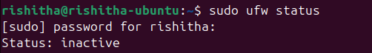

8. Hardening and recommendations
UFW was enabled with a default-deny inbound policy and a single allow rule for port 80, and the web server still responded afterwards.
Applied on the Ubuntu server:
- sudo ufw default deny incoming
- sudo ufw default allow outgoing
- sudo ufw allow 80/tcp
- sudo ufw enable
sudo ufw status verbose then showed Status: active, logging on (low), default deny (incoming) / allow (outgoing) / disabled (routed), and one rule: 80/tcp ALLOW IN from Anywhere (IPv4 and IPv6).
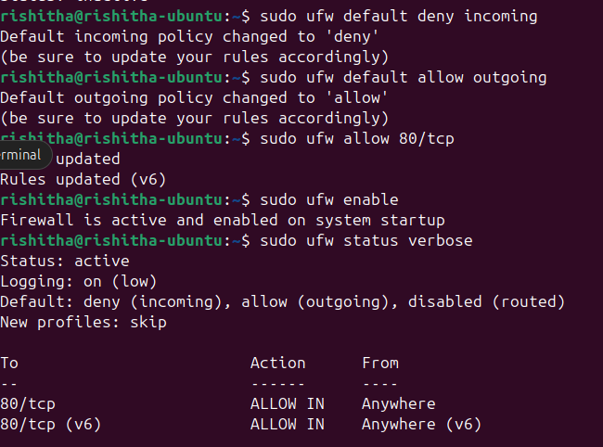
Verification. From Kali, curl -I http://192.168.206.5 still returned HTTP/1.1 200 OK from nginx/1.24.0 (Ubuntu) after the firewall was enabled.
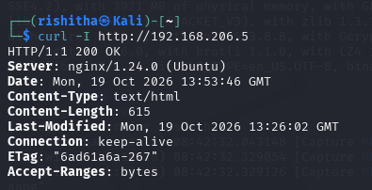
Recommendations (suggested next steps, not carried out in this project):
- Serve the site over HTTPS (port 443 with a TLS certificate) so traffic is encrypted, addressing finding 2.
- Hide the Nginx version (server_tokens off;), addressing finding 3.
- Limit the port 80 rule to the hosts that need it, instead of Anywhere.
- Re-run the Nmap scan after hardening to confirm the exposed ports.

9. Conclusion
The lab network was set up with two virtual machines on 192.168.206.0/24, verified with ping, curl and DNS tests, scanned with Nmap, and captured with Wireshark. The assessment found an inactive firewall, unencrypted HTTP and a disclosed server version on the Ubuntu web server. Enabling UFW with default-deny inbound and an allow rule for port 80 closed the firewall gap while keeping the web service reachable.

